**1. INTRODUCTION TO XBOX & KINECT**

**XBOX:**

Microsoft Xbox One takes you to a new generation filled with entertainment and new games. Here games push the boundaries of practicality and lets the television obey each of your command. It allows you to listen to music while you play games and lets you shift easily from TV to movies to music to your favourite game instantly. A new gaming experience with Xbox One.

The new Microsoft Xbox One has been designed in a way that it will be the most advanced and entertaining gaming console ever. This gaming console has for the first time developed a gaming OS that has been amalgamated with the super powerful Windows OS. It is also powered with the 8-core x86 processor that allows you to shift instantly between the game and the apps. Microsoft Xbox One is always ready. It wakes up instantly when you want to play. This means less waiting time and more gaming time.

Split Your Screen and not your Time! With Snap enabled in the console you can chat with friends and play games at the same time. You just need to split your screen and you go do both on the same screen.

The new gaming console Microsoft Xbox One's Controller has got even better with more than 40 technology innovations made in it. The latest and new Impulsive Triggers give you precise fingertip feedback giving you more realistic experience. Microsoft has much efficient thumbsticks, D-pad and contours that give you an improved precision and comfort.

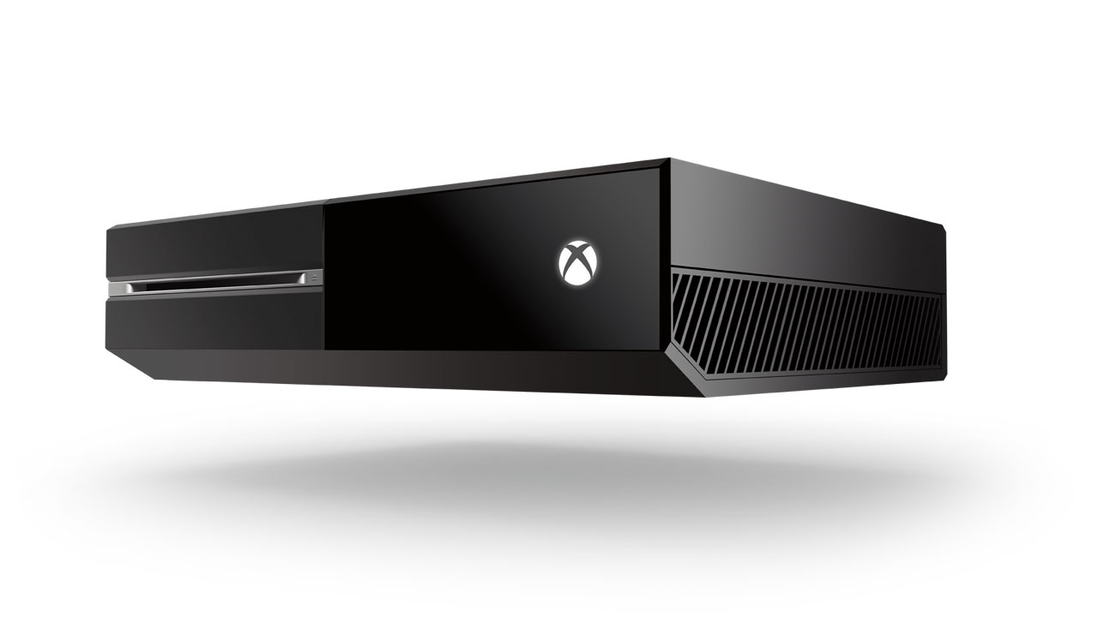

Fig 1.1: XBOX console

The new Xbox One has re-engineered completely. This time it more precise, responsive, and intuitive. The new and unparalleled voice, motion and vision technology gives you a new experience while gaming like never before. It allows you to sign in automatically when you enter the room and speed up in the game with simple gestures. You can also navigate your favourite TV Show with your voice.

It includes a 1080p, HD camera that captures video at **0 frames per second. All-new, active-infrared capabilities increase precision, allowing it to work in nearly any lighting condition and expanding field of view to accommodate a greater variety of room sizes. Microsoft proprietary Time-of-Flight technology measures the time it takes individual photons to rebound off you to create unprecedented accuracy and precision.

|  |  |
| --- | --- |
| ***Property*** | ***Detail*** |
| Developer | Microsoft |
| Manufacturer | Flextronics, Foxconn |
| Product family | Xbox |
| Type | Video game console |
| Generation | Eighth generation |
| Release date | •       November 22, 2013 |
| •       November 22, 2013 (some countries, 2014 for others) |
| Introductory price | US$499/€499/£429 |
| Units sold | 3.9 million (as of December 31, 2013) |
| Media | Blu-ray, DVD, CD |
| Operating system | Xbox OS , Windows custom kernel and a hypervisor |
| CPU | Custom 1.75 GHzAMD 8 core APU (2 Quad-Core Jaguar modules) |
| Memory | 8 GB DDR3 (5 GB available to games) |
| Storage | 500 GB internal hard drive |
| Display | 4K, 1080p, and 720p resolutions |
| Graphics | 853 MHz AMD Radeon GCN architecture (inside of APU) |
| Sound | 7.1 surround sound |
| Input | HDMI |
| Controller input | Xbox One controller, Kinect for Xbox One, SmartGlass |
| Camera | 1080p Kinect camera |
| Connectivity | Wi-Fi IEEE 802.11n, Ethernet, 3 × USB 3.0, HDMI 1.4 in/out,S/PDIF out, IR-out, Kinect port |
| Online services | Xbox Live |
| Weight | 7 lbs (pounds) |
| Backward | No |
| compatibility |
| Predecessor | Xbox 360 |
| Website | xbox.com |

Table 1: System Configuration of XBOX ONE

**KINECT:**

Kinect (codenamed in development as Project Natal) is a line of motion sensing input devices by Microsoft for Xbox 360 and Xbox One video game consoles and Windows PCs. Based around a webcam-style add-on peripheral, it enables users to control and interact with their console/computer without the need for a game controller, through a natural user interface using gestures and spoken commands. The first-generation Kinect was first introduced in November 2010 in an attempt to broaden Xbox 360's audience beyond its typical gamer base. A version for Windows was released on February 1, 2012. Kinect competes with several motion controllers on other home consoles, such as Wii Remote Plus for Wii and Wii U, PlayStation Move/PlayStation Eye for PlayStation 3, and PlayStation Camera for PlayStation 4.

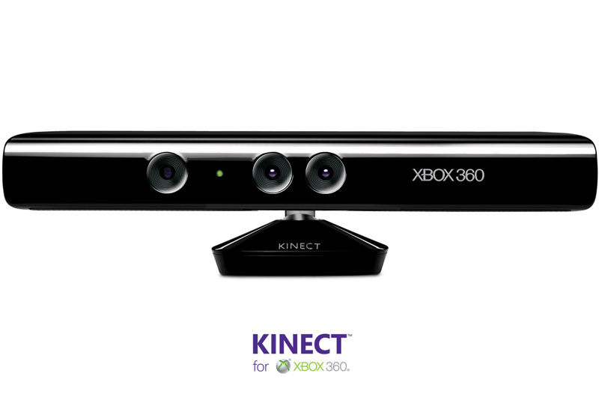

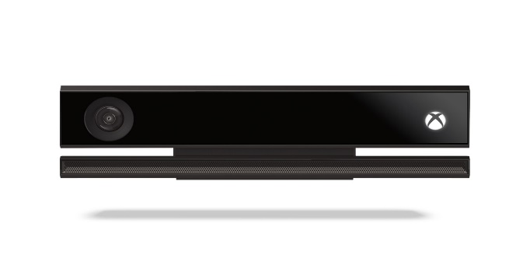

Fig 1.2: XBOX KINECT

**2. HISTORY OF KINECT**

Kinect was first announced on June 1, 2009 at E3 2009 under the code name "Project Natal". Following in Microsoft's tradition of using cities as code names, “Project Natal" was named after the Brazilian city of Natal as a tribute to the country by Brazilian-born Microsoft director Alex Kipman, who incubated the project. The name Natal was also chosen because the word natal means "of or relating to birth", reflecting Microsoft's view of the project as "the birth of the next generation of home entertainment".

Three demos were shown to showcase Kinect when it was revealed at Microsoft's E3 2009 Media Briefing: Ricochet, Paint Party and Milo & Kate. A demo based on Burnout Paradise was also shown outside of Microsoft's media briefing. The skeletal mapping technology shown at E3 2009 was capable of simultaneously tracking four people, with a feature extraction of 48 skeletal points on a human body at 30 Hz.

It was rumoured that the launch of Project Natal would be accompanied with the release of a new Xbox 360 console (as either a new retail configuration, a significant design revision and/or a modest hardware upgrade). Microsoft dismissed the reports in public and repeatedly emphasized that Project Natal would be fully compatible with all Xbox 360 consoles. Microsoft indicated that the company considers it to be a significant initiative, as fundamental to Xbox brand as Xbox Live, and with a launch akin to that of a new Xbox console platform. Kinect was even referred to as a "new Xbox" by Microsoft CEO Steve Ballmer at a speech for Executives' Club of Chicago. When asked if the introduction will extend the time before the next-generation console platform is launched (historically about 5 years between platforms), Microsoft corporate vice president Shane Kim reaffirmed that the company believes that the life cycle of Xbox 360 will last through 2015 (10 years).

During Kinect's development, project team members experimentally adapted numerous games to Kinect-based control schemes to help evaluate usability. Among these games were Beautiful Katamariand Space Invaders Extreme, which were demonstrated at Tokyo Game Show in September 2009. According to creative director Kudo Tsunoda, adding Kinect-based control to pre-existing games would involve significant code alterations, making it unlikely for Kinect features to be added through software updates.

Although the sensor unit was originally planned to contain a microprocessor that would perform operations such as the system's skeletal mapping, it was revealed in January 2010 that the sensor would no longer feature a dedicated processor. Instead, processing would be handled by one of the processor cores of Xbox 360's Xenon CPU. According to Alex Kipman, Kinect system consumes about 10-15% of Xbox 360's computing resources. However, in November, Alex Kipman made a statement that "the new motion control tech now only uses a single-digit percentage of Xbox 360's processing power, down from the previously stated 10 to 15 percent." A number of observers commented that the computational load required for Kinect makes the addition of Kinect functionality to pre-existing games through software updates even less likely, with concepts specific to Kinect more likely to be the focus for developers using the platform.

The Xbox 360 S and E models have dedicated ports for the Kinect, removing the need for an external power supply. On March 25, Microsoft sent out a save the date flier for an event called the "World Premiere 'Project Natal' for Xbox 360 Experience" at E3 2010. The event took place on the evening of Sunday, June 13, 2010 at Galen Center and featured a performance by Cirque du Soleil. It was announced that the system would officially be called Kinect, a portmanteau of the words "kinetic" and "connect", which describe key aspects of the initiative. Microsoft also announced that the North American launch date for Kinect will be November 4, 2010. Despite previous statements dismissing speculation of a new Xbox 360 to accompany the launch of the new control system, Microsoft announced at E3 2010 that it was introducing a redesigned Xbox 360, complete with a connector port ready for Kinect. In addition, on July 20, 2010, Microsoft announced a Kinect bundle with a redesigned Xbox 360, to be available with Kinect launch.

On June 16, 2011, Microsoft announced its official release of its SDK for non-commercial use. On July 21, 2011, Microsoft announced that the first ever white Kinect sensor would be available as part of "Xbox 360 Limited Edition Kinect Star Wars Bundle", which also includes custom a Star Wars-themed console and controller, and copies of Kinect Adventures and Star Wars Kinect. Previously, all Kinect sensors had been glossy black.

On October 31, 2011, Microsoft announced launching of the commercial version of Kinect for Windows program with release of SDK to companies. David Dennis, Product Manager at Microsoft, said, "There are hundreds of organizations we are working with to help them determine what's possible with the tech".

On February 1, 2012, Microsoft released the commercial version of Kinect for Windows SDK and told that more than 300 companies from over 25 countries are working on Kinect-ready apps.

**3. TECHNOLOGY INVOLVED IN KINECT**

Kinect builds on software technology developed internally by Rare, a subsidiary of Microsoft Game Studios owned by Microsoft, and on camera technology by Israeli developer Prime Sense, which developed a system that can interpret specific gestures, making completely hands-free control of electronic devices possible by using an infrared projector and camera and a special microchip to track the movement of objects and individuals in three dimensions. This 3D scanner system called Light Coding employs a variant of image-based 3D reconstruction.

Kinect sensor is a horizontal bar connected to a small base with a motorized pivot and is designed to be positioned lengthwise above or below the video display. The device features an "RGB camera, depth sensor and multi-array microphone running proprietary software", which provide full-body 3D motion capture, facial recognition and voice recognition capabilities. At launch, voice recognition was only made available in Japan, United Kingdom, Canada and United States. Mainland Europe received the feature later in spring 2011.Currently voice recognition is supported in Australia, Canada, France, Germany, Ireland, Italy, Japan, Mexico, New Zealand, United Kingdom and United States. Kinect sensor's microphone array enables Xbox 360 to conduct acoustic source localization and ambient noise suppression, allowing for things such as headset-free party chat over Xbox Live.

The depth sensor consists of an infrared laser projector combined with a monochrome CMOS sensor, which captures video data in 3D under any ambient light conditions. The sensing range of the depth sensor is adjustable, and Kinect software is capable of automatically calibrating the sensor based on gameplay and the player's physical environment, accommodating for the presence of furniture or other obstacles.

Described by Microsoft personnel as the primary innovation of Kinect, the software technology enables advanced gesture recognition, facial recognition and voice recognition. According to information supplied to retailers, Kinect is capable of simultaneously tracking up to six people, including two active players for motion analysis with a feature extraction of 20 joints per player. However, Prime Sense has stated that the number of people the device can "see" (but not process as players) is only limited by how many will fit in the field-of-view of the camera.

This infrared image shows the laser grid Kinect uses to calculate depth, The depth map is visualized here using colour gradients from white (near) to blue (far).Reverse engineering has determined that the Kinect's various sensors output video at a frame rate of 9 Hz to 30 Hz depending on resolution. The default RGB video stream uses 8-bit VGA resolution (640 × 480 pixels) with a Bayer colour filter, but the hardware is capable of resolutions up to 1280x1024 (at a lower frame rate) and other colour formats such as UYVY.

The monochrome depth sensing video stream is in VGA resolution (640 × 480 pixels) with 11-bit depth, which provides 2,048 levels of sensitivity. The Kinect can also stream the view from its IR camera directly (i.e.: before it has been converted into a depth map) as 640x480 video, or 1280x1024 at a lower frame rate. The Kinect sensor has a practical ranging limit of 1.2–3.5 m (3.9–11.5 ft.) distance when used with the Xbox software. The area required to play Kinect is roughly 6 m2, although the sensor can maintain tracking through an extended range of approximately 0.7–6 m (2.3–19.7 ft.). The sensor has an angular field of view of 57° horizontally and 43° vertically, while the motorized pivot is capable of tilting the sensor up to 27° either up or down. The horizontal field of the Kinect sensor at the minimum viewing distance of ~0.8 m (2.6 ft.) is therefore ~87 cm (34 in), and the vertical field is ~63 cm (25 in), resulting in a resolution of just over 1.3 mm (0.051 in) per pixel. The microphone array features four microphone capsules and operates with each channel processing 16-bit audio at a sampling rate of 16 kHz.

Because the Kinect sensor's motorized tilt mechanism requires more power than the Xbox 360's USB ports can supply, the device makes use of a proprietary connector combining USB communication with additional power. Redesigned Xbox 360 S models include a special AUX port for accommodating the connector, while older models require a special power supply cable (included with the sensor) that splits the connection into separate USB and power connections; power is supplied from the mains by way of an AC adapter.

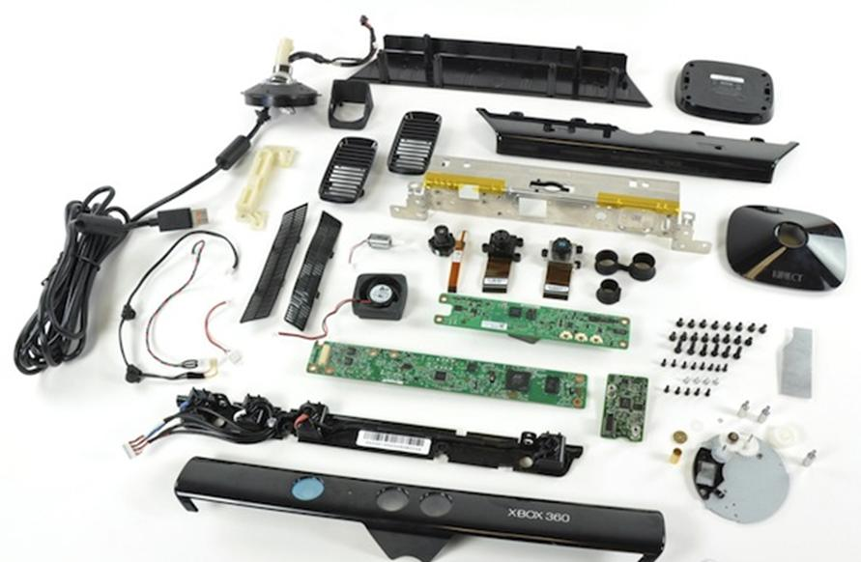

Fig 3.1: Kinect contents

**4. THE KINECT SENSOR**

The innovative technology behind Kinect is a combination of hardware and software contained within the Kinect sensor accessory that can be added to any existing Xbox 360. The Kinect sensor is a flat black box that sits on a small platform, placed on a table or shelf near the television you're using with your Xbox 360. Newer Xbox 360s have a Kinect port from which the device can draw power, but the Kinect sensor comes with a power supply at no additional charge for users of older Xbox 360 models. For a video game to use the features of the hardware, it must also use the proprietary layer of Kinect software that enables body and voice recognition from the Kinect sensor [source: Rule].

There's a trio of hardware innovations working together within the Kinect sensor:

Colour VGA video camera - This video camera aids in facial recognition and other detection features by detecting three colour components: red, green and blue. Microsoft calls this an "RGB camera" referring to the colour components it detects.

Depth sensor - An infrared projector and a monochrome CMOS (complimentary metal-oxide semiconductor) sensor work together to "see" the room in 3-D regardless of the lighting conditions.

Multi-array microphone - This is an array of four microphones that can isolate the voices of the players from the noise in the room. This allows the player to be a few feet away from the microphone and still use voice controls.

A further look at the technical specifications for Kinect reveal that both the video and depth sensor cameras have a 640 x 480-pixel resolution and run at 30 FPS (frames per second). The specifications also suggest that you should allow about 6 feet (1.8 meters) of play space between you and the Kinect sensor, though this could vary depending on where you put the sensor [source: Microsoft Store].

The Kinect hardware, though, would be nothing without the breakthrough software that makes use of the data it gathers. Leap forward to the next page to read about the "brain" behind the camera lens. Kinect Software Learns from "Experience"

Kinect's software layer is the essential component to add meaning to what the hardware detects. When you first start up Kinect, it reads the layout of your room and configures the play space you'll be moving in. Then, Kinect detects and tracks 48 points on each player's body, mapping them to a digital reproduction of that player's body shape and skeletal structure, including facial details [source: Rule].

In an interview with Scientific American, Alex Kipman, Microsoft's Director of Incubation for Xbox 360, explains Project Natal's approach to developing the Kinect software. Kipman explains, "Every single motion of the body is an input," which creates seemingly endless combinations of actions [source: Kuchinskas]. Knowing this, developers decided not to program that seemingly endless combination into pre-established actions and reactions in the software. Instead, it would "teach" the system how to react based on how humans learn: by classifying the gestures of people in the real world.

To start the teaching process, Kinect developers gathered massive amounts of data from motion-capture in real-life scenarios. Then, they processed that data using a machine-learning algorithm by Jamie Shotton, a researcher at Microsoft Research Cambridge in England. Ultimately, the developers were able to map the data to models representing people of different ages, body types, genders and clothing. With select data, developers were able to teach the system to classify the skeletal movements of each model, emphasizing the joints and distances between those joints. An article in Popular Science describes the four steps Kinect's "brain" goes through 30 times per second to read and respond to your movements [source: Duffy].

The Kinect software goes a step further than just detecting and reacting to what it can "see." Kinect can also distinguish players and their movements even if they're partially hidden. Kinect extrapolates what the rest of your body is doing as long as it can detect some parts of it. This allows players to jump in front of each other during a game or to stand behind pieces of furniture in the room.

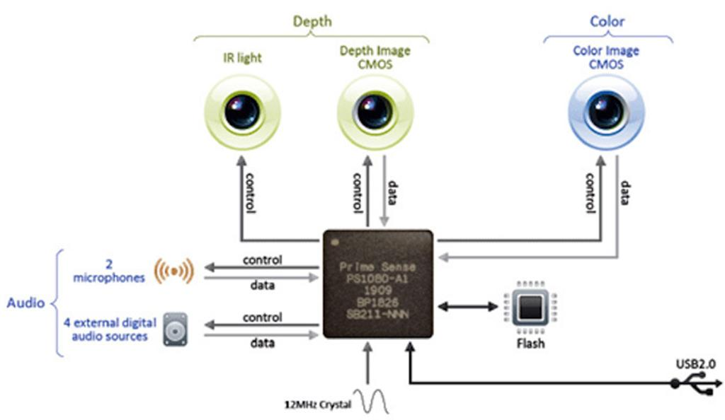

Fig 4.1: KINECT Anatomy

A Game Changer for the Game Console Market?

Just as the gasoline engine freed vehicles from horses to pull them, Kinect frees the video game player from needing a controller to use the system. While Kinect may not change the world on the scale of the gasoline engine, its potential impact on the video game console market is no less profound. Plus, we have yet to discover what the technology could mean for other industries.

As previously mentioned in this article, Microsoft Kinect provides an interactive video game experience through motion detection like the Nintendo, but without the need for physical controllers. YouTube videos of people trying out Kinect at E3 show breathless, happy players jumping, kicking and dancing more vigorously than they could with Nintendo Wii controllers in hand or under feet. As of this writing, there's no word on how Nintendo will respond with its own product line.

From a price perspective alone, the Wii is the better bargain until you have three or more people playing at one time. At full retail price, the Wii console with one controller (including Nunchuk) is $199, and each additional controller plus Nunchuk could set you back $60. The Kinect sensor retails at $149 and includes a copy of "Kinect Adventures." The device must be attached to an Xbox 360 console, and if you don't have one yet, the Xbox 360 with 4 GB of internal flash memory costs $199. You can get the same unit bundled with a Kinect and "Kinect Adventures" for $299 [source: Microsoft Store]. This doesn't count purchasing additional games, batteries (for the Wii controllers), or a subscription to Xbox Live to connect and play over the Internet (no extra cost for Wii owners to play online games).

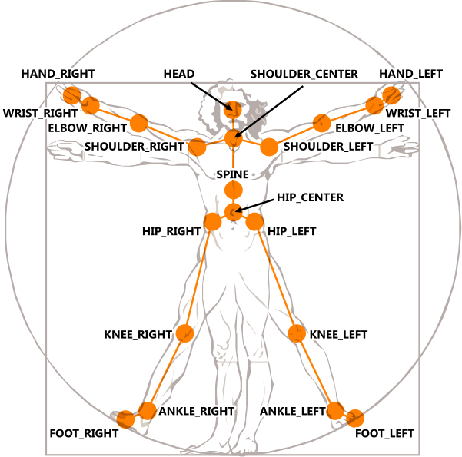

Fig 4.2: KINECT Skeleton data

For players who prefer the tactile feedback of props, the Nintendo Wii and PlayStation Move will have the advantage. For example, holding a video game gun that lets you aim and pull the trigger at the screen might give you a better first-person-shooter experience than merely mimicking holding and firing a gun. To capture this audience, Microsoft might respond with games that use, or even require, props.

Will Kinect's innovation go beyond the entertainment industry? At the time of this writing, it was too soon to tell. However, there was already buzz about how it could be used in healthcare and education. Imagine how Kinect could be used for tracking your progress in physical therapy, driving your car when you can't use a steering wheel, or simulating a day in the life of a soldier during the American Revolution.

The game is on for Kinect. Start your own adventure with some of the links on the next page.

On June 1, 2009, Microsoft's annual E3 press conference announced the development of a motion-sensitive gaming technology code-named Project Natal. The promotional video on YouTube, posted the same day as the press release, portrayed Project Natal as a controller-less way to play games, watch movies and keep in touch with friends. The video featured game control by just moving your body, plus facial and voice for each player. At the end of the video, Microsoft gave viewers a peek at the hardware: a sleek, black, low-profile box sitting on a small platform, looking at you with two camera-like eyes in the middle and a green light offset to the left.

At the heart of the project was a 3-D detection digital camera. Reports suggested that the technology likely originated with Israeli start-up 3DV, a company Microsoft had acquired just two months before. Press images of the 3DV camera from months before were significantly different from the Project Natal form factor: a small upright box with a series of purple lights and a protruding camera lens in the center.

The natural response from video game console enthusiasts was to compare the technology to the Nintendo. Nintendo had revolutionized console gaming when it released the Wii in 2006. The Wii meant that, for the first time, the game controller was more than just a series of buttons: It also detected the movement of the controller and allowed the player to interact with the game based on that movement. For three years, the Wii was unmatched for bringing motion detection to home video game consoles.

The central part of the Wii experience was the controller. The movement of the controller was the means of transmitting the player's movement to the console. In fact, Nintendo and other vendors created enhancements so the player could hold an object similar to that in the game (like a guitar or a tennis racket), or so the player could get motion feedback (a "rumble" effect). The Wii Balance Board controller added even more interactive options for players, detecting pressure from standing on it and shifting your weight.



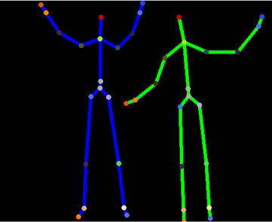



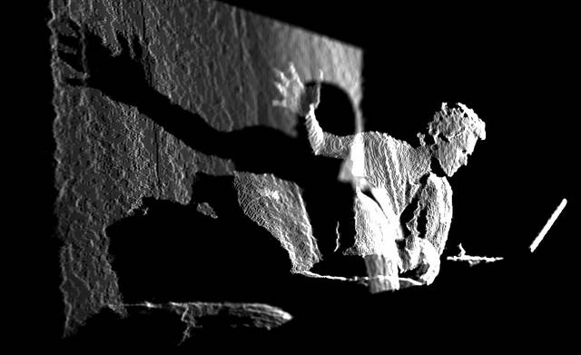

Fig 4.3: KINECT Sensor data

Project Natal promised a dramatic leap forward from the Wii as it seemed to have overcome the need for any physical controller. Even better: Those with existing Xbox 360 consoles could use it without buying a completely new console. For the year following its original announcement, Microsoft gave celebrities and talk show hosts a chance to try it out. The result was a series of TV segments and YouTube videos buzzing about the good, the bad, and the creepy of the Project Natal experience. By the next E3 event, Project Natal, officially branded Microsoft Kinect, was one of the most anticipated Microsoft products in years, with a line of Kinect-based games to appeal to the same diverse audience as the Wii.

**5. WHAT KINECT DOES?**

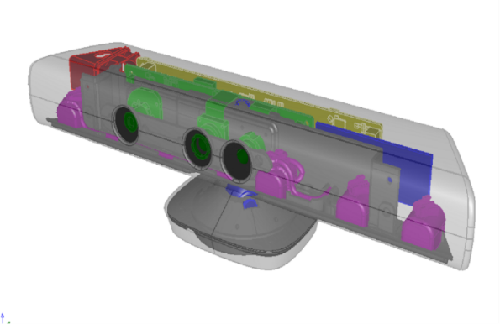

Fig 5.1: KINECT Hardware

Eyes of Kinect are made by an INFRARED MEASUREMENT SYSTEM-Laser beam is send from the objective and received by sensor as can be seen above. These sensors can move to adjust for the distance and height. This device produces MAP OF DEPTH to objects in a room. The device can thus ’see’ in bad light or in darkness. Before the use it is TRAINED with movements of persons in the room. You can see on the right that in infrared the beam makes lots of measurement dots

The area required to play Kinect is roughly 6m²s. Kinect recognizes voice IN ROOMS and can be used for voice control of applications. Kinect recognizes persons and body movements which is used in applications. But before this Kinect is TRAINED interactively like shown in pictures. After the training person and body movements will be recognized.

More than one person can be identified in a scene. Games and interactive playing (sports, dancing, arcade, action, strategy).More applications: exercising, rehabilitation, child development, Control of devices by voice, gestures, Automation and robotics, Medical Science sit is the first practical natural user interface for machines communicating with people. It is combining acoustical and visual sense. It is recognizing full body movements, even complicated ones. It finds application not only in games but also in the field of medical sciences and robotics. After selling a total of 8 million units in its first 60 days, the Kinect holds the Guinness World Record of being the "fastest selling consumer electronics device".

Fig 5.2: KINECT Mechanism

**6. ADVANTAGES**

1. Truly next gen system philosophy with slick, fast UI, voice and gesture commands and seamless integration of all sofa-based entertainment, Skype, fast switching, multi-tasking, snap mode has a thousand possibilities

2. Games launched instantly without disc switching due to installs

3. Add as much extra storage as desired through external HDD

4. Kinect 2.0 included – finally frees up developers to explore the tech and its possibilities for integration into core gaming, unnoticeable latency, provides high quality Skype camera, and will be great for UI and media control via voice command and gesture

5. Smart Glass can finally show its potential now it will be linked directly via Wi-Fi to the console (rather than the old SG to web, web to Xbox method that lagged a lot)

6. Controller looks amazing with “surround rumble” and every area subtly improved, and overhauled D-pad

7. GAMES – the launch window games for Xbox One contains loads of exclusive titles I’m actually interested in – Ryse, Forza, Dead Rising 3, Killer Instinct, Project Spark, Titanfall, Quantum Break, D4

8. General good track record with online services and reliable media and UI performance

9. Sharing family is an amazing feature. Really surprised me how generous the terms are.

10. Huge cloud advantage to 300,000 servers

**7. DISADVANTAGES**

1. Refusal to allow self-publishing on Xbox One is a huge mistake in my mind, and will rob the platform of some of the most interesting games next gen. It’s a possible deal breaker for me.

2. 24 hour check in is an obvious and necessary way of protecting against piracy within a system where games are fully installed, instantly launched and sharable with friends digitally – BUT – lack of any fail-safes for times the internet goes is a major concern. Another possible deal breaker in my mind.

3. Slight lack of power over PS4 could become an issue later in the generation, and could lead to superior PS4 versions of cross platform games

4. Huge size of the console, obviously due to overheating paranoia, makes it less of an attractive proposition in my entertainment centre

5. Higher price over PS4

6. Used game restrictions only bother me in that it seems to favour big businesses like GAME and Gamestop. Will my local games shop be allowed to sell on Xbox One games? I don’t patronise the used game industry personally as I think it is choking the real games making industry, but I don’t like these big-corporate favouring policies.

7. Fear over what could happen at the end of the generation. While it is more logical to think that they’d just run an update that removed the online check, there is the spectre of risk that all your paid-for games could become unplayable.

**8. CONCLUSION**

The XBOX ONE is a fantastic machine. I have to credit Microsoft for an excellent User Interface that is both easy to use and good looking, something that doesn't usually go together with Microsoft products. I have to say that the Xbox Live! Arcade is where many of you will spend a lot of your time, it’s a great idea and being able to download demos finally is a godsend as trying before you buy is vital for those kind of games and you really can get hours of fun for very little money.

The High Definition graphics that the XBOX ONE produces are wonderful there is no doubt, games like Call of Duty 2, Racing 3 stunned me. We really are entering an age where photo realistic graphics in games is becoming a reality.

A new generation of games and entertainment. Where games push the boundaries of realism. And television obeys your every command. Where listening to music while playing a game is a snap. And you can jump from TV to movies to music to a game in an instant. Where your experience is custom tailored to you. And the entertainment you love is all in one place. Welcome to the all-in-one, Xbox One.

The most advanced multiplayer.

Powered by over 300,000 servers, with millions of players around the world, and more than a decade of multiplayer experience, Xbox Live is the proven place to play the best exclusive titles and all the biggest blockbusters. And now, everyone is invited to experience smarter matchmaking, less waiting, and better performance with Xbox Live on Xbox One. You can even record and share your moments of glory, or live broadcast your gameplay with Twitch.

Breakthrough technology that keeps getting better.

Xbox One is designed to start ahead and always stay ahead. Experience cloud-powered performance and intelligence on Xbox Live. Get instant recognition and enhanced voice control with our 1080p HD Kinect Sensor. And with our industry-leading controller with immersive Impulse Triggers, nothing will hold you or your games back.

**9. REFERENCES**

* Johnny Lee’s Wii Projects:
  + <http://johnnylee.net/projects/wii/>
* The Future 360: Project Natal takes shot at Wii
  + <http://news.cnet.com/8301-17938_105-10253586-1.html>
* Open-Kinect (Open-Source Kinect Driver)
  + <http://openkinect.org/wiki/Main_Page>
* Kinect for Windows (Official SDK):
  + <http://www.microsoft.com/en-us/kinectforwindows/>
* How Microsoft Kinect Works:
  + <http://electronics.howstuffworks.com/microsoft-kinect2.htm>
* How Motion Detection Works in Xbox Kinect:
  + <http://www.wired.com/gadgetlab/2010/11/tonights-release-xbox-kinect-how-does-it-work/>
* Microsoft drops internal Natal chip:
  + <http://www.gamesindustry.biz/articles/microsoft-drops-internal-natal-chip_1>
* Kinect SDK Basics
  + <http://channel9.msdn.com/Series/KinectQuickstart/>